**Artificial Intelligence (AI)** is a branch of computer science that focuses on creating systems that can perform tasks that normally require human intelligence. These tasks include understanding natural language, recognizing patterns, solving problems, learning from experience, and making decisions.

**Think, Act/behave Humanly and Rationally.**

**AI Problems:**

1. *Classification:* Classifying data into predefined categories based on its characteristics.
2. *Regression:* Predicting continuous outcomes based on input variables.
3. *Clustering:* Grouping similar data points together based on their characteristics.
4. *Association Rule Learning:* Discovering interesting relationships between variables in large datasets.
5. *Anomaly Detection:* Identifying outliers or unusual patterns in data.
6. *Natural Language Processing (NLP):* Understanding and processing human language, including tasks like sentiment analysis, named entity recognition, and text generation.
7. *Computer Vision:* Extracting information from images and videos, including tasks like object recognition, image classification, and image segmentation.
8. *Recommendation Systems:* Suggesting items or content to users based on their preferences and behavior.

**AI Techniques:**

1. *Machine Learning:* A subset of AI that involves teaching machines to learn from data and make predictions or decisions without being explicitly programmed. Techniques include supervised learning, unsupervised learning, and reinforcement learning.
2. *Natural Language Processing (NLP):* Techniques for analyzing and understanding human language, including syntactic and semantic analysis, named entity recognition, sentiment analysis, and language generation.
3. *Computer Vision:* Techniques for analyzing and understanding visual data, including convolutional neural networks (CNNs), which are particularly effective for tasks like object recognition and image classification.
4. *Knowledge Representation and Reasoning:* Techniques for encoding knowledge in a format that machines can understand and manipulate, along with algorithms for reasoning with that knowledge to make decisions or solve problems.
5. *Robotics:* The intersection of AI and robotics, involves developing algorithms and systems that enable robots to perceive their environment, make decisions, and perform tasks autonomously.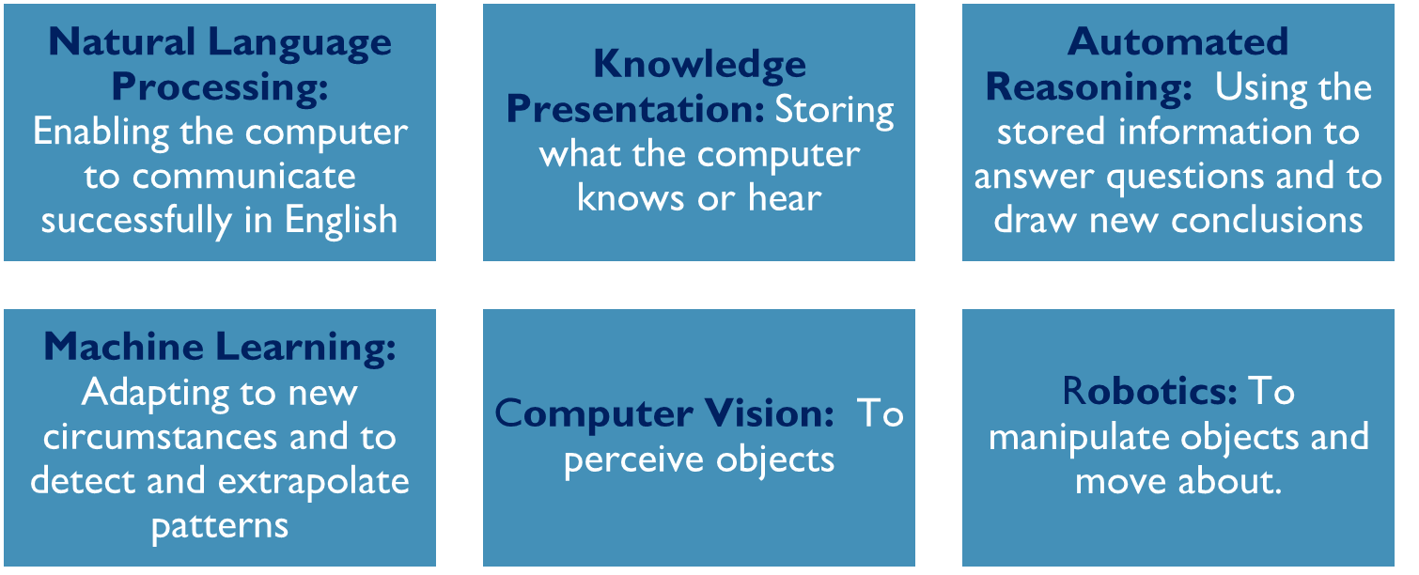
6. *Expert Systems:* AI systems that emulate decision-making abilities of human experts in a specific domain by encoding their knowledge in a set of rules or heuristics.

**AI techniques: Required capabilities to act humanly (Turing Test- Alan Turing):-**Measure of a machine's ability to exhibit intelligent behavior indistinguishable from that of a human. Human judge interacts with machine & human through text-based interface without knowing which is which. If the judge cannot reliably distinguish between them based on their responses, the machine is said to have passed the Turing Test and demonstrated human-like intelligence.

**Agents:** They are entities that perceive their environment through sensors and act upon that environment through actuators.

**Components of AI Agents:**

1. *Sensors:* Perceive the environment.
2. *Actuators:* Act upon the environment.
3. *Percept:* Complete set of inputs received by the agent at a given time.
4. *Percept Sequence:* History of everything the agent has perceived.
5. *Agent Function:* Maps from percept histories to actions.
6. *Agent Program:* Concrete implementation that runs on the physical architecture to produce the agent function.
7. *Action:* Operation involving an actuator.

**Properties of Agents:**

1. *Rationality:* Agents make decisions that are expected to achieve their objectives or goals based on the available information and their knowledge of the environment. Rationality implies selecting actions that maximize expected utility or achieve the best outcome given the circumstances.
2. *Autonomy:* Agents can operate independently, making decisions and taking actions without direct human intervention. Autonomy enables agents to adapt to changing environments and pursue goals without constant supervision.
3. *Reactivity:* Agents respond in real time to changes in their environment or stimuli, reacting to events or inputs promptly. Reactivity allows agents to interact dynamically with the environment and other agents, adjusting their behavior as needed to achieve their goals or fulfill their tasks.

**Types of Agents:-**

*Simple Reflex Agents:*

1. Make decisions based solely on the current percept.
2. Limited intelligence and no memory requirements.
3. Can lead to infinite loops in certain situations.
4. Examples include thermostats and simple game strategies.

*Model-Based Reflex Agents:*

1. Utilize a model of the world to make decisions.
2. Maintain an internal state representing unobserved aspects of the environment.
3. Update the state based on percept history and actions.
4. Examples include fly buzzing around a window or light.

*Goal-Based Agents:*

1. Choose actions to achieve predefined goals.
2. Goals describe desirable situations.
3. Decision-making involves considering goal satisfaction and action consequences.
4. Search and planning techniques are used to achieve goals.

*Utility-Based Agents:*

1. Consider not only the achievement of goals but also the quality of outcomes.
2. Utility function maps states to real numbers representing degree of happiness or preference.
3. Allows comparison of different world states based on their utility.
4. Enables agents to make decisions that optimize utility rather than just achieving goals.

*Learning Agents:*

1. Have the ability to learn from past experiences.
2. Start with basic knowledge and adapt through learning.
3. Composed of learning element, critic, performance element, and problem generator.
4. Learn to improve performance based on feedback & experiences from environment.

**PEAS** analysis is a framework used to design intelligent agents. It involves specifying the Performance measure, Environment, Actuators, and Sensors of the agent.

1. Performance Measure: Criteria for evaluating the success of the intelligent agent. Specifies what the agent is expected to achieve in the given task. It reflects the overall success or failure of the agent in its environment.
2. *Environment:* External context or surroundings in which the intelligent agent operates. It defines conditions, constraints, & dynamics of the agent's task. Crucial for designing an agent that can effectively interact with & adapt to its surroundings.
3. *Actuators:* Mechanisms or components responsible for carrying out actions in the environment. These are the effectors that execute the decisions made by the agent based on its internal processing. Can include motors, limbs, or any other tools that allow the agent to influence its surroundings.
4. *Sensors:* Means by which the intelligent agent perceives and gathers info about its environment. Provide the input data that the agent uses to make decisions and take action. Include cameras, microphones, touch sensors, or any other devices that collect relevant information from the environment.

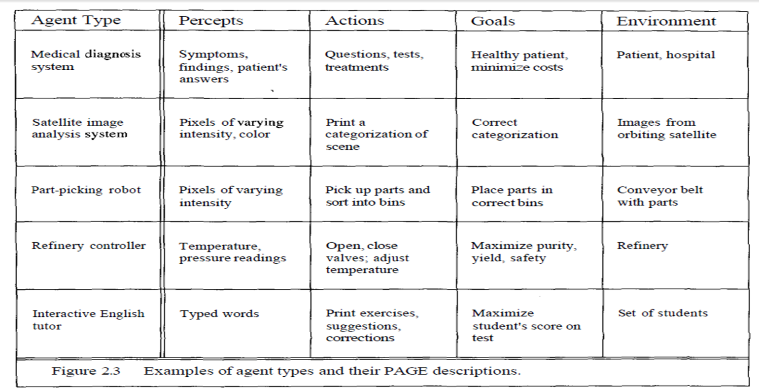

**Agent environment types:**

1. *Fully Observable (Accessible vs. Inaccessible):*

Accessible: Agent's sensors provide complete, accurate, up-to-date info about environment.

Inaccessible: Agent lacks complete information about the environment's state.

1. *Deterministic (vs. Stochastic):*

Deterministic: Next state of environment is determined by current state & agent's actions.

Stochastic: Next state is influenced by randomness or uncertainty.

1. *Episodic (vs. Sequential):*

Episodic: Agent's experience is divided into atomic episodes, and actions in each episode depend only on that episode.

Sequential: Agent's actions depend on the sequence of events and interactions across multiple episodes.

1. *Static (vs. Dynamic):*

Static: Environment remains unchanged while the agent is deliberating.

Dynamic: Environment changes due to external processes beyond the agent's control.

1. *Discrete (vs. Continuous):*

Discrete: Finite, clearly defined percepts and actions.

Continuous: Infinite or unbounded range of percepts and actions.

1. *Single Agent (vs. Multiagent):*

Single Agent: Agent operates alone in the environment.

Multiagent: Multiple agents interact with each other and the environment.

The process of **solving problems by searching** involves formulating a goal, identifying potential actions, and navigating through states to find a solution.

Route-finding problem from Arad to Bucharest using search:

1. *Formulating the Goal:* The agent's goal is to drive to Bucharest due to the constraints of a nonrefundable ticket and an expiring visa.
2. *Problem Formulation:* Decide the town to drive to from Arad: Sibiu/Timisoara/ Zerind.
3. *Search Process:* Agent explores different possible sequences of actions to reach Bucharest.. Each town becomes a new state, and the agent chooses one option to consider further while putting others aside.
4. *Search Tree:* The initial state in Arad is the root of the search tree. Leaf nodes represent states that have no successors or have not been expanded yet. At each step, the search algorithm selects a leaf node to expand, guiding the exploration towards the goal state.
5. *Search Strategy:* Different search strategies may prioritize certain states over others based on criteria such as cost, distance, or heuristic information.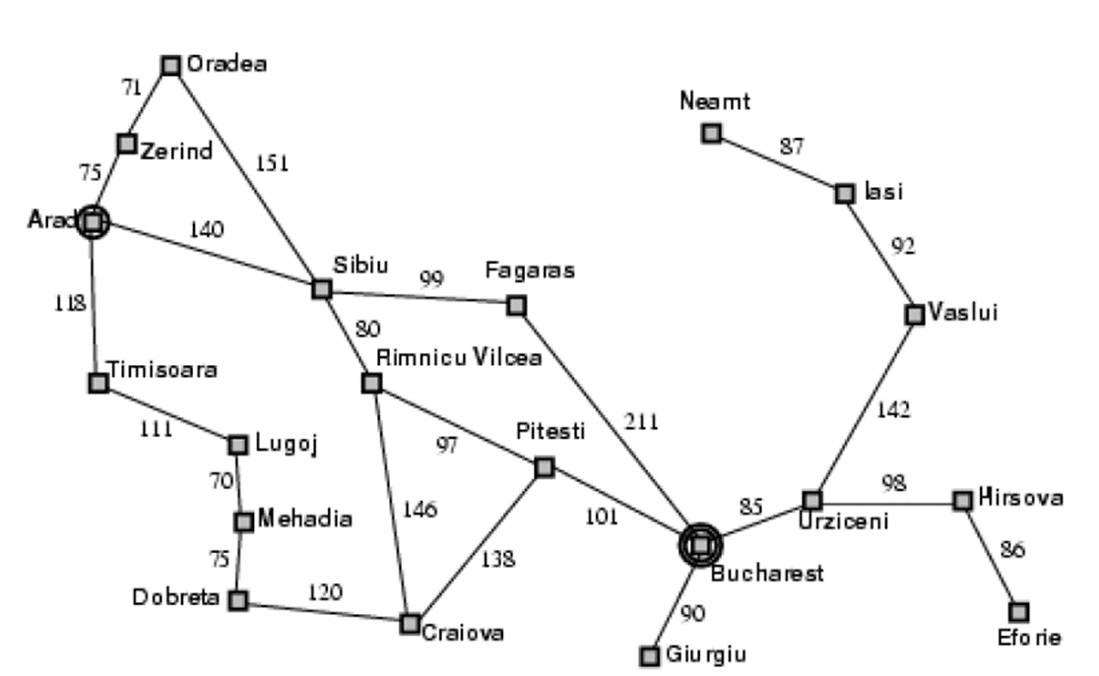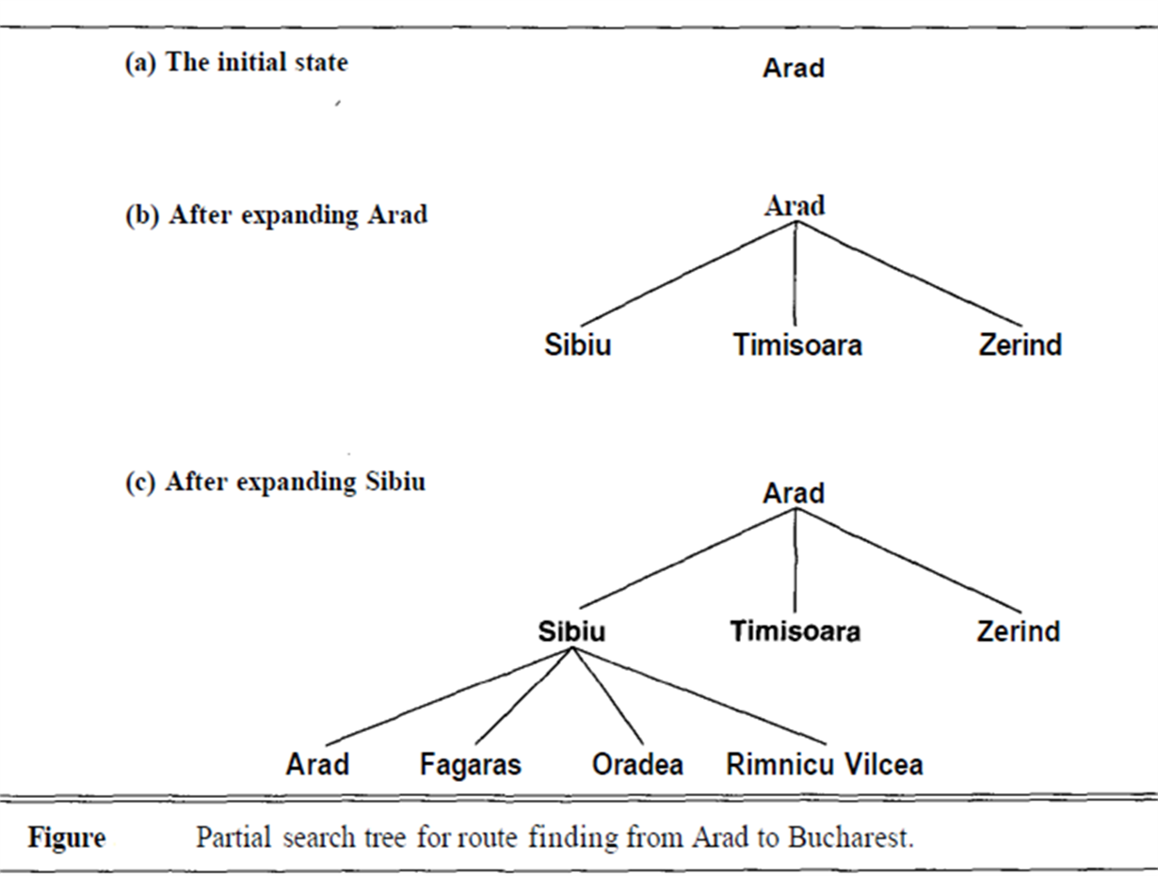

**The general search algorithm** involves distinguishing between the state space and the search tree, where the state space represents all possible configurations of the problem, while the search tree represents the exploration process.

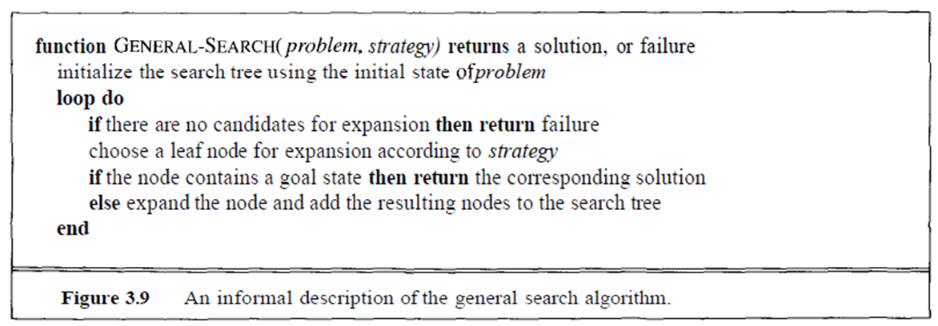

Components: STATE, PARENT-NODE, OPERATOR, DEPTH, PATH-COST.  
A node is a data structure used in the search algorithm, representing elements in the search tree. A state represents a configuration or set of configurations of the world, independent of the search process.

**Search Strategies Evaluation:**

1. Completeness: Does the strategy guarantee to find a solution when one exists?
2. Time Complexity: How long does it take to find a solution?
3. Space Complexity: How much memory is required to perform the search?
4. Optimality: Does the strategy find highest-quality solution among possible solutions?

**Types of Search Strategies:**

1. *Blind Search:* DFS, BFS, Iterative Deepening Search.
2. *Informed Search:* Bidirectional Search.
3. *Other Techniques:* Constraint Satisfaction, Adversary Search.

